Data Analysis RMA Report
- DISCOVERY
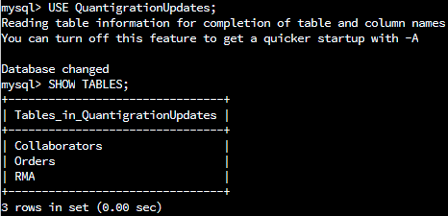
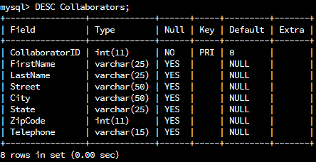
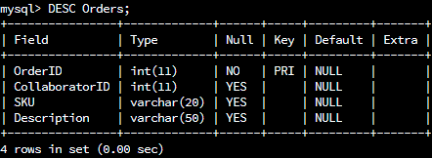
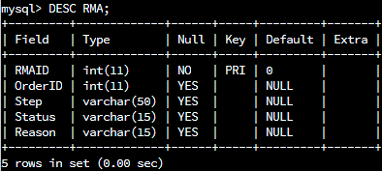
- ANALYSIS

  - Analyze the number of returns by state and describe your findings in your report.
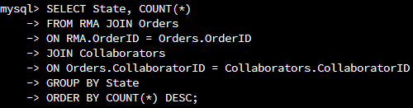
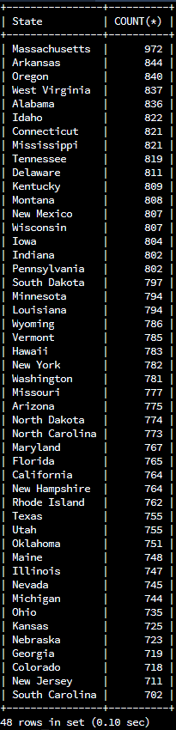
Massachusetts is home of the most RMAs, with a total of 972 authorized returns.
Next is Arkansas with 844 returns, followed by Oregon with 840 returns.
The state with the least number of returns is South Carolina at only 702 total.

- Analyze the percentage of returns by product type and describe your findings in your report.
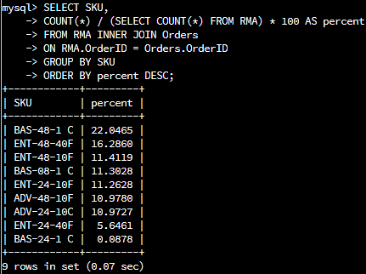
BAS-48-1 C is our most returned product at about 22% of total authorized returns.
Next is ENT-48-40F at 16%, followed by ENT-48-10F at approximately 11%.
Our least returned product is BAS-24-1 C, coming in at only 0.09% of total returns.

- SUMMARY

Massachusetts is home of the most RMAs, with a total of 972 authorized returns.
Next is Arkansas with 844 returns, followed by Oregon with 840 returns.
The state with the least number of returns is South Carolina at only 702 total, which is a difference of about 32% from the RMA count in Massachusetts:
$$\frac{\left|972-702\right|}{\frac{\left(972+702\right)}{2}}×100\%≈32\%$$

BAS-48-1 C is our most returned product at 22% of total authorized returns.
Next is ENT-48-40F at 16%. That’s a difference of approximately 30%:
$$\frac{\left|22.0465\%-16.2860\%\right|}{\frac{\left(22.0465\%+16.2860\%\right)}{2}}×100\%≈30\%$$

This is followed by ENT-48-10F, representing 11% of total returns.
Our least returned product is BAS-24-1 C, coming in at only 0.09% of total returns.

It’s worth taking note of our most ordered products:
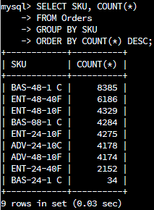

The number of returns for any given product is directly correlated with the quantity of purchases that have been made for that product:
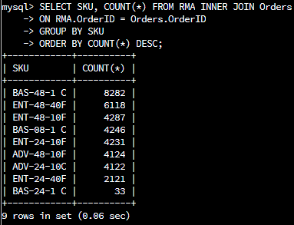

This is to be expected; however, too many products are being returned.
For example, BAS-48-1 C has been purchased 8385 times and returned 8282 times.
That’s only 103 items, or 98.77%, being kept after purchase:
$$\frac{8282}{8385}×100\%≈98.77\%$$

Although this does not seem like viable information, as Quantigration has grown
substantially at quite a high rate.

Analyst: Matthew Pool
Date: February 8, 2023

